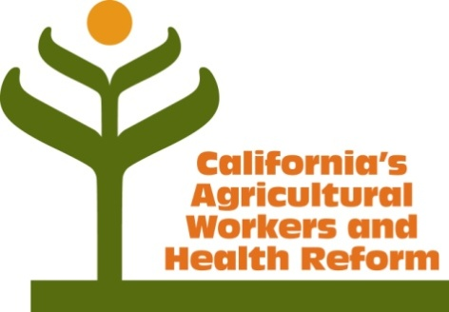
Health Coverage for California Farm Workers

I. Demographics and current coverage
- Agriculture is a $45 billion industry in California, the largest in the nation.
- There are approximately 1 million Californians in farmworker families.
- Approximately 60 to 80 percent of farmworkers are not authorized to work in US.
- Fewer than 20 percent of farmworkers currently receive employer provided health benefits.
  - The Ag plans have been operating under waivers that allowed them to provide coverage with capped benefits. These waivers expire in 2014.
  - Collectively, the Taft-Hartley and MEWA plans in California cover no more than 100,000 lives including dependents. There are additional employer self-funded plans.

II. Coverage options under Affordable Care Act
- Employer provided coverage:
  - Beginning 2015, for full-time farmworkers that are employed by “large employers”.
  - Seasonal workers are covered, but only after they meet any 60 day waiting period.
  - Employers beginning to offer “skinny” benefits that provide coverage only for preventive services, coupled with a high deductible bronze plan. They may meet the “minimum essential coverage” requirement to help employers and employees avoid tax penalties.
- Medi-Cal or Exchange subsidies for documented workers when not offered employer benefits.
- Coverage by county indigent programs in limited number of agricultural counties that provide services or coverage for undocumented persons.
- Direct primary and preventive care provided by community and migrant health centers; emergency care at hospitals. (20% of farmworkers report having a medical visit at a clinic in past year.)
- Direct primary care provided to workers by large growers (e.g. Reiter and Paramount).

III. Challenges
- Coverage in the off-season for those with employer coverage.
- Affordability of employer provided “bronze” level or 60 percent actuarial value coverage due to high deductibles and co-pays.
- Value of “skinny” plans that provide only minimum preventive services, but insulate employers from first level of “pay or play” penalties.
- No Medi-Cal or Covered CA for approximately 60 to 80 percent due to immigration status.
- County services and coverage for undocumented is very limited in agricultural counties. Only two of the top 10 California counties with the highest concentration of farmworkers cover undocumented persons, and one of them, Fresno, is seeking court permission to stop serving the undocumented.

IV. Possible solutions
- Create coverage vehicle that maximizes employer contributions while providing coverage in off season and allows aggregation of multiple employer contributions.
- Expanded public benefits for undocumented workers in California (e.g. Lara proposal).
- Increased flexibility for existing ag plans to restructure benefits and enroll from multiple employers.
- Increased funding for safety net clinics to provide care.
- Trust fund for employer and philanthropic contributions (e.g. AB175).
- Immigration reform to provide pathway to legalization and access to benefits.

