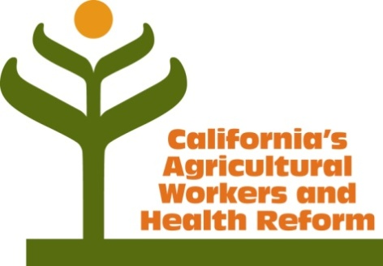
New Models of Health Care Coverage for California Farm Workers

Stakeholder Advisory Group Meeting
Monday, March 10, 2014
10 am to 2 pm

10:00 to 10:20 am | Welcome and Introductions  Purpose of project and role of advisory group | Joel Diringer, Facilitator
10:20 am – 11:15 am | Group updates: Affordable Care Act implementation in ag community | All
11:15 am to 12 noon | Legislative and regulatory updates  - ACA large employer rules  - State legislation on covering undocumented Californians (SB1005 – Lara)  - Other legislation | Ed McClements, Barkley Insurance
12:00 – 12:20 pm | Break for lunch
12:20 – 12:35 pm | Updated data on agricultural worker coverage from National Agricultural Workers Survey | Ed Kissam
12:35 – 1:00 pm | Group discussion:  Pros and cons of limited benefit plans
1:00 – 1:30 pm | Group discussion:  Moving forward: should we focus on “care” or “coverage?” | All
1:30 pm – 2:00 pm | Next steps
 | Preparation of legislative briefing on ag health coverage issues
 | Additional stakeholder engagement
 | Next advisory group meeting – Sacramento
For further information, contact Joel Diringer, joel@diringerassociates.com; 805-546-0950.

